# SIS – SoftUni Information Services

SIS is a combination of a Web Server and a MVC Framework. Ultimately it is designed to mimic Microsoft’s IIS and ASP.NET Core. Following several Lab documents you will build all components of the SIS.

# SIS: Handmade HTTP Server

Problems for exercises and homework for the [“C# Web Development Basics” course @ SoftUni](https://softuni.bg/courses/csharp-web-development-basics).

Following to the end this document will help you to create your own very simple HTTP Server. Later in the course we will extend it by adding sessions, cookies etc. We will eventually build a MVC Framework, with which we can build MVC Web Application which will be hosted on the Handmade HTTP Server.

But before that, let’s have a little practice on asynchronous tasks.

## Chronometer

The Chronometer is one of the easiest examples of an asynchronous processes. Let’s implement a simple Chronometer.

Create an interface IChronometer like this:

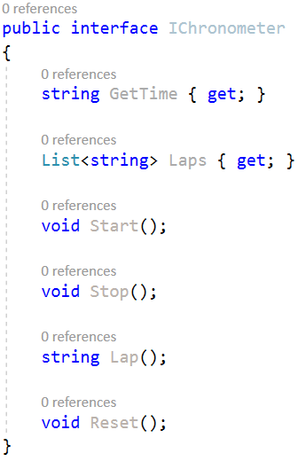

... and implement a class Chronometer, that implements it.

Implement a program which provides a Chronometer functionality, that responds to several commands from the user input:

start – starts counting time in milliseconds, seconds and minutes.

stop – stops the process of counting time, but the counted time remains.

lap – creates a lap at the current time.

laps – returns all of the currently recorded laps.

time – returns the currently recorded time.

reset – stops the Chronometer, resets the currently recorded time and deletes all of the currently recoded laps.

exit – stops and exits the program.

Heres an example screenshot of the functionality:

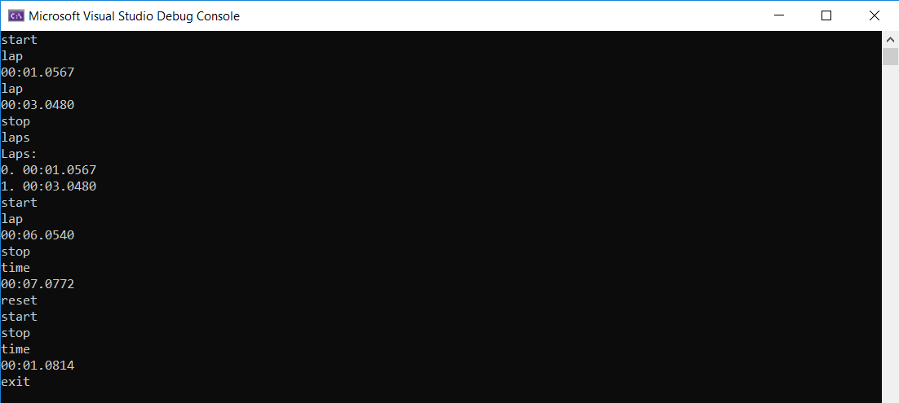

The time is outputted in the following format: "{minutes}:{seconds}:{milliseconds}", each of them should be **padded** with **zeros**.

Upon **making** a **lap** you should print the **time** at which it was made.

Requesting **all laps** should print them in the following format:

Laps:  
0. {lap1}  
1. {lap2}  
...

In case there are no laps, you should print "Laps: no laps".

## Parallel MergeSort

MergeSort is one of the fastest and most efficient sorting algorithms. It disolves a collection into 2 halves and then disolves each half into 2 halves, and so on it repeats the process, until the halves are made up of 1 element. Then it merges them back in a sorted way, eventually merging the whole collection back. It is a Divide and Conquer recursive algorithm. Due to its recursiveness, which essentially represents running several instances of the same process, it can be distributed into several threads – making it a parallel merge sort. A very fast algorithm in the hands of a casual processor.

* Implement a simple merge sort, you can find the algorithm’s description and pseudocode anywhere in the net, but here’s a [link](https://softwareengineering.stackexchange.com/questions/324593/recursion-in-merge-sort-algorithm-how-is-it-obvious-to-use-this-type-of-recursi/324596#324596).
* Here’s a [link](https://www.random.org/integer-sets/), for generating large sets of random numbers, in a formatted form, so that you can have test data. Test your algorithm with at least **10000** elements.

Implement a Parallel MergeSort algorithm, but be careful, put a limit to the threads distribution. You don’t want to put int.MaxValue threads into work, or your computer will hate you.

## Asynchronous SIS WebServer

### SIS.WebServer Project Architecture

The **WebServer Project** holds the main classes that **establish** the **connection** over **TCP Link**. These classes are used the ones from the **HTTP Project**. The Project expose several classes, which should be used from the outside, in order to **implement** an **application**.

**Server Class**

The Run() method should be used to **start** the **listening process**. Тhe listening process should be **asynchronous** to ensure **concurrent client functionality**.

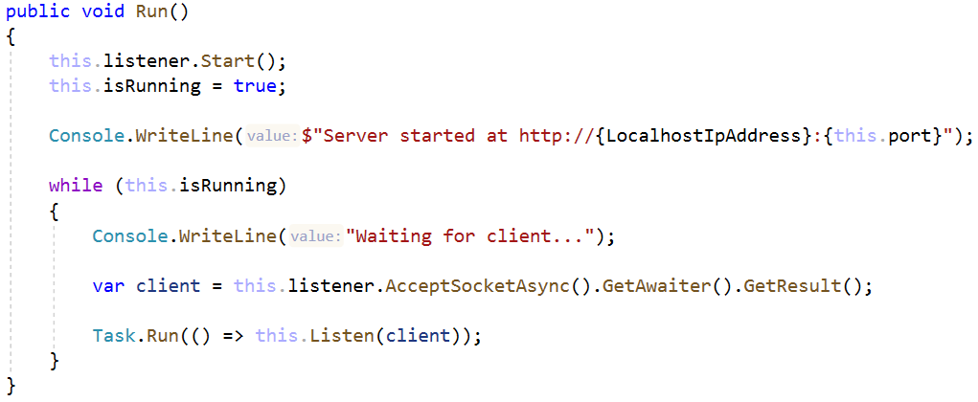

We also have a little message notifying us that nothing has exploded brutally in the process.

The Listen() method is the main processing of the **client connection**:

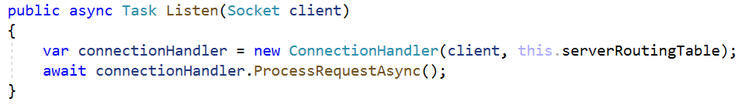

**ConnectionHandler Class**

The ConnectionHandler class is the **client** **connection processor**. It receives the **connection**, **extracts** the **request** **string data** from it, **processes** it **using** the **routing table**, and then **sends back** the **Response** in a byte format, throughout the **TCP link**.

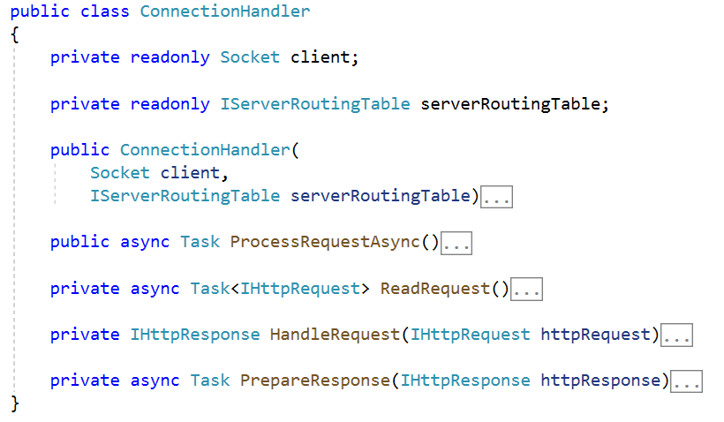

The constructor should just **initialize** the **socket** (the **wrapper object** for a **client connection**) and the **routing table**.

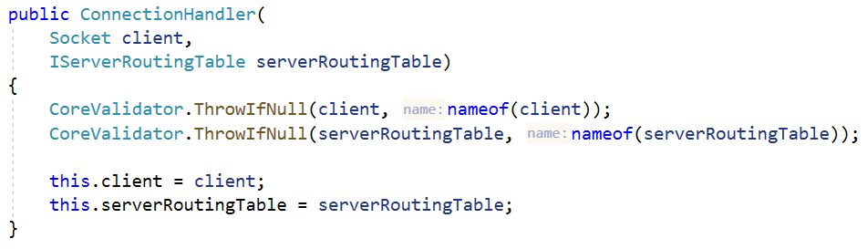

The ProcessRequestAsync() method is an **asynchronous** method which contains the main functionality of the class. It uses the other methods to **read** the **request**, **handle** it, **generate** a **response**, **send** it to the **client**, and finally, **close** the **connection**.

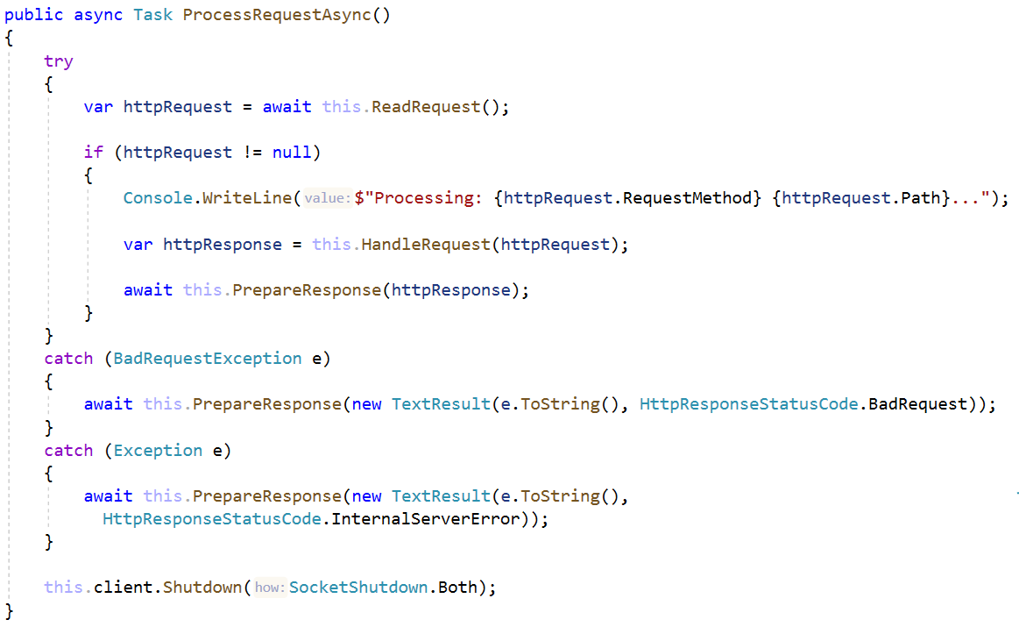

The ReadRequest() method is an **asynchronous** method which reads the **byte data** from the **client connection**, **extracts** the **request string data** from it, and then **maps** it to a HttpRequest object.

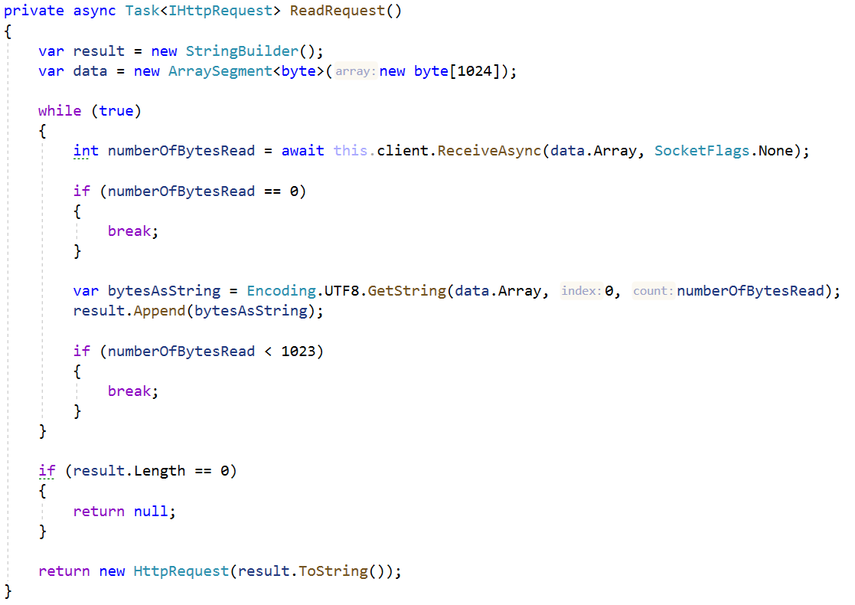

As you can see the **Requests** are quite limited to **1024 bytes**. This is intentional.

The HandleRequest() method **checks** if the **routing table** has a **handler** for the **given Request**, using the **Request’s** **Method** and **Path**.

* If there is **no such handler** a “Not Found” **Response** is returned.
* If there is a **handler**, its **function** is **invoked**, and its resulting **Response** – returned.

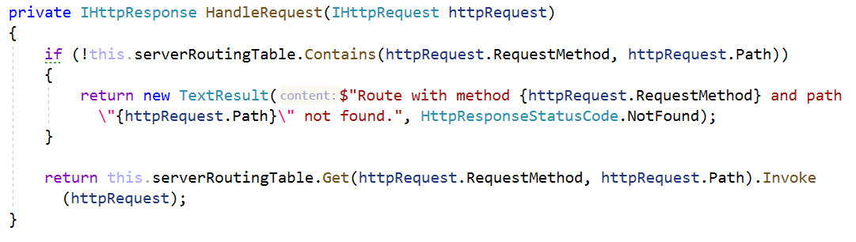

The PrepareResponse() method **extracts** the **byte data** from the **Response**, and **sends** it to the **client**.

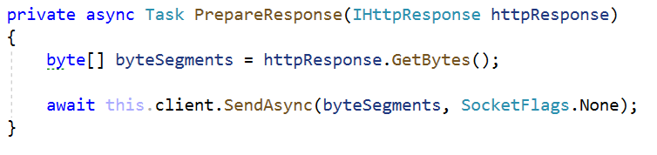

And with that we are finished with the ConnectionHandler and the **WebServer Project** as a whole. Now, before we embark on a journey to implement applications with our **SIS**. Let’s first check a very simple **Hello World! Demo app**.

## Hello, World!

Implement a third project called SIS.Demo. Reference both the SIS.HTTP and SIS.WebServer projects to it.

Create the following classes:

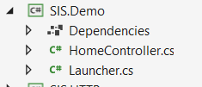

### HomeController

The HomeController class should hold a single method – Index() which looks like this:

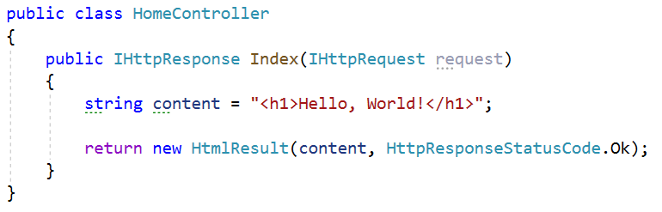

### Launcher

The Launcher class should hold the Main method, which instantiates a Server and **configures** it to **handle** **requests** using the ServerRoutingTable.

**Configure** only the “/” route with a **lambda function** which **invokes** the HomeController.Index method.

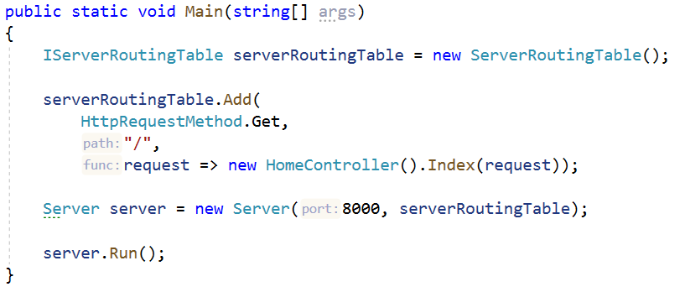

Now run the SIS.Demo project, and you should see this, if everything up until now was done correctly:

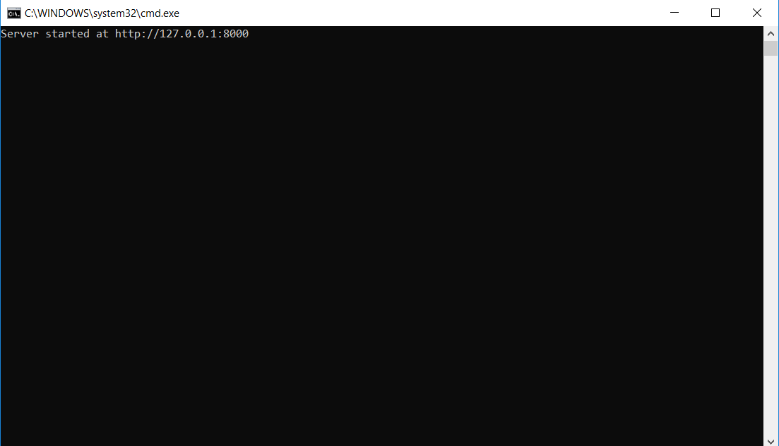

Open your browser, then go to localhost:8000. And you should see this.

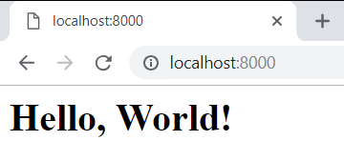

**Congratulations**! You have completed your async **Hello World app** with the SIS!

# State Management

In this lab you will configure the Server to be stateful. This means that we will add a few classes for Cookies and Sessions, in order to maintain states about our clients.

Start by **adding** the following **2 namespaces** to the SIS.HTTP project.

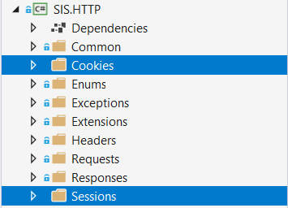

And now let’s get to the main thing...

## Cookies

### HttpCookie Class

The first thing we need to do is add the functionality for the **Cookies**, they will be the most **primitive element** to our **State Management**.

Create a class, called HttpCookie, in the Cookies namespace. The class should have the following properties:

* Key – a **string**, representing the **key** (or the **name**) of the **Cookie**.
* Value – a **string**, representing the **value** (or the **content**) of the **Cookie**.
* Expires – a **DateTime**, representing the **expiration time** of the **Cookie**.
  + This **property** will be initialized with an **integer**, which will represent **DAYS**, from the **current moment**.
* Path - a **string**, representing the default **path** of the **Cookie**.
* IsNew – a **boolean**, which will be used to **define** if the **Cookie** is **freshly created**. This way we will know if the **Server** has **created** the **Cookie** (for example when the **Client logs in**) or the **Cookie** comes from the **Client**.
* HttpOnly - a **boolean** representing if the **Cookie** has HttpOnly flag, by default **true**.

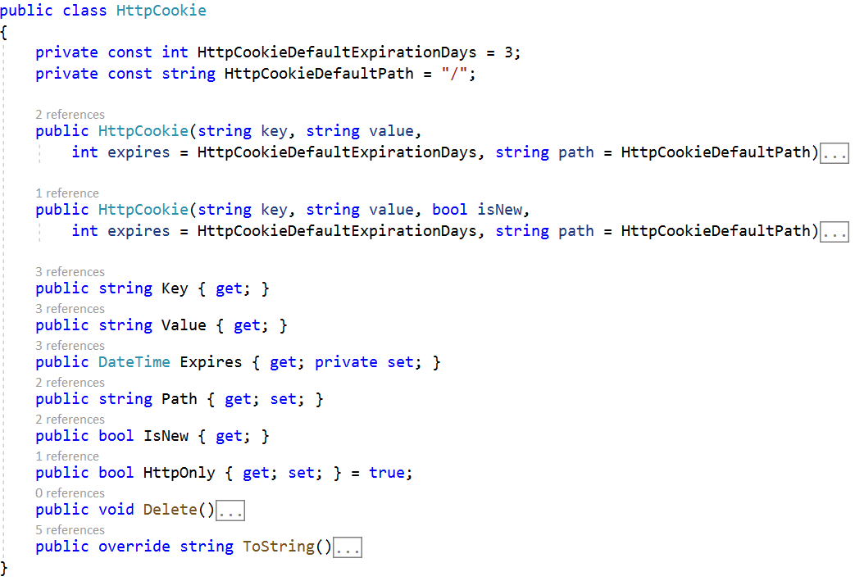

The ToString() method formats the **Cookie** **parameters** in **Web-ready format**.

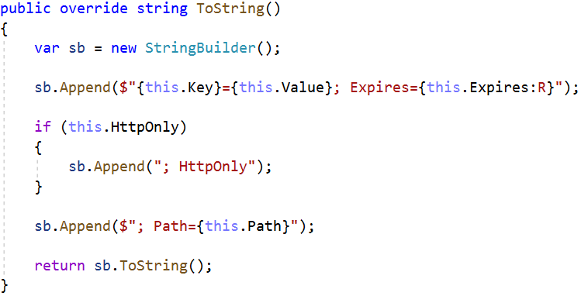

**Delete()** method deletes the Cookie.

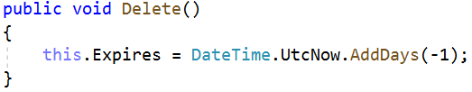

There are **2 constructors** which control the way the IsNew property is **initialized**, due to its behaviour:

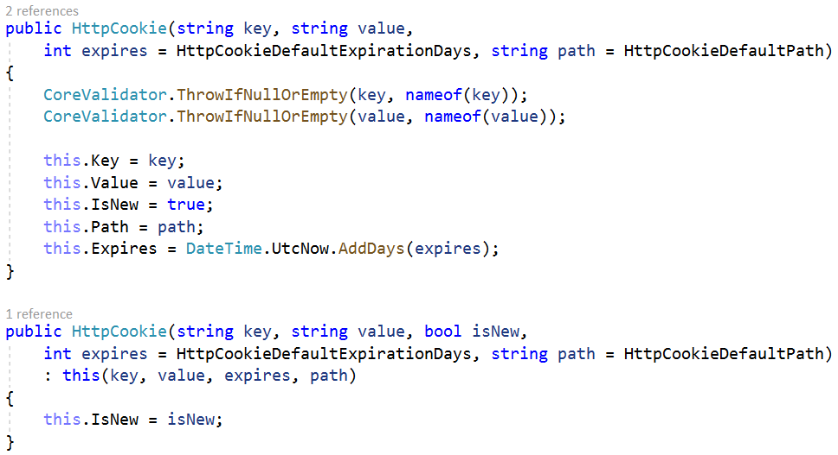

And with this we have completed our HttpCookie class. Now it’s time to create a **Repository-like** class for it.

### HttpCookieCollection Class

Create an interface, called IHttpCookieCollection in the Cookies namespace. It should look like this.

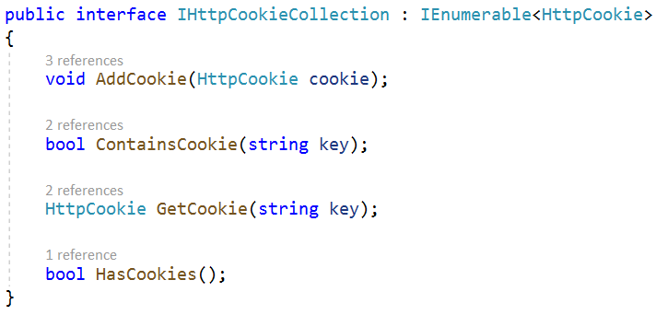

The classes that implement the interface and its methods should have the following functionality:

* AddCookie() – **adds** the given Cookie to a **collection** of HttpCookies.
* ContainsCookie() – returns a **boolean** result, on whether the **given key** is **contained** in the HttpCookie collection.
* GetCookie() – **extracts**, form the HttpCookie collection, the Cookie with the **given key**, and **returns it**.
* HasCookies() – returns a **boolean** result, on **whether** there are **ANY** **cookies** in the HttpCookie collection.

The class is yours to implement. : )

The HttpCookieCollection class should also have a ToString() override method, that should format the Cookies in Web-Ready format:

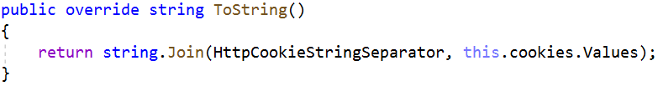

Now let’s add the Cookies to our main communication classes – The HttpRequest & HttpResponse.

### HttpRequest

Add an IHttpCookieCollection property to the HttpRequest class. Initialize it from the constructor. Write a method ParseCookies(), which checks the HttpHeadersCollection for a Header with name “Cookie” and if there is, extracts its **string value**, **formats** it, **parses** it and **adds** it to the HttpCookieCollection.

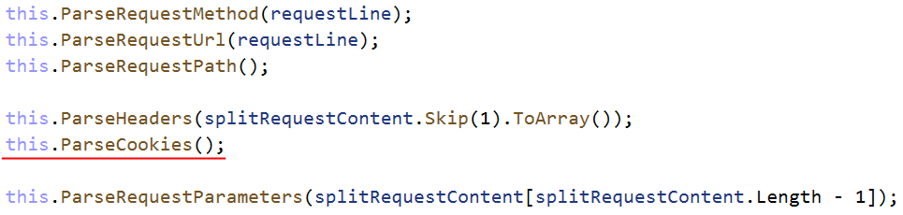

### HttpResponse

Add an IHttpCookieCollection property to the HttpResponse class. Initialize it from the constructor. Write a public method AddCookie(), which **adds** the **given** Cookie to the HttpCookieCollection.

Reformat the ToString() method so that it includes the Cookies, if there are any, with a “Set-Cookie” **name**, and **values** – separated by a **semi colon** and a **space**.

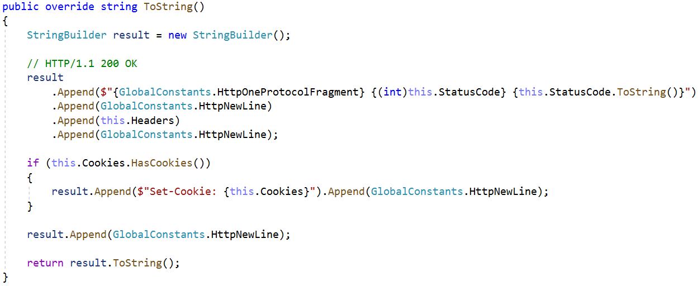

And with this we are done with the Cookies’ implementation in our HTTP Server. This will be enough for now. As the time passes by, we will obviously refactor them, extend them, optimize them and manipulate them in many ways, but let’s be patient.

**NOTE**: Each of the **public methods** and **properties** you’ve **added** should **be** **also added** to the **interfaces** of the **corresponding classes**.

## Sessions

The next big thing we need to implement is the Sessions. They are **Server-side State Management** mechanism, and are the most important element of the Stateful functionality.

### IHttpSession

Let’s start with the interface. Create an interface, called IHttpSession, in the Sessions namespace. The HttpSession should have a **collection** of **parameters** and a Id which is a **string**. The interface should look like this:

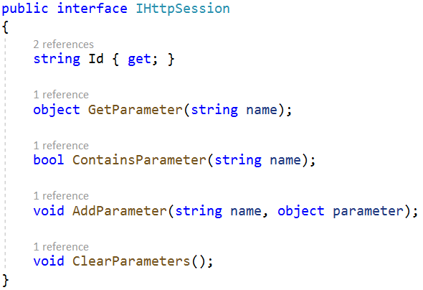

As you can see there are **several methods** for **accessing** the **collection** of **parameters**, as it will be **private**. This is everything we need as public behaviour.

The classes that implement the **interface** and its **methods** should have the following functionality:

* Id – just a property with a getter.
* GetParameter() – **extracts**, form the **parameter collection**, the **parameter** with the **given name**, and **returns it**.
* ContainsParameter() – returns a **boolean** result, on whether a **parameter** with **given name** is **contained** in the collection.
* AddParameter() – **adds** the given parameter with the **given name** to a **key-value-pair** **collection** of **parameters**.
* ClearParameters() – **clears** the **collection**, emptying it.

The class is yours to implement. : )

**Note**: The **constructor** of the **class** should **initialize** the **collection** and the Id. Here’s a hint on how it should look:



The HttpSessions are implemented, but there is something missing. The **Server** needs to store the Sessions somewhere.

### HttpSessionStorage

Create a class named HttpSessionStorage, in the Sessions namespace. We will use this **class** to **store** our **sessions**, in a **Dictionary-like** collection. But our **Server** will work with **many Clients parallelly**, which means that the collection must be **async-friendly**, or **thread-safe**.

Well, there is a collection that just does the trick.

We would also need a **Session Key**, something with which our Session will be sent as a Cookie to the Client.   
Let’s call it “SIS_ID”. This will be the **SIS**’s **Session Key**.

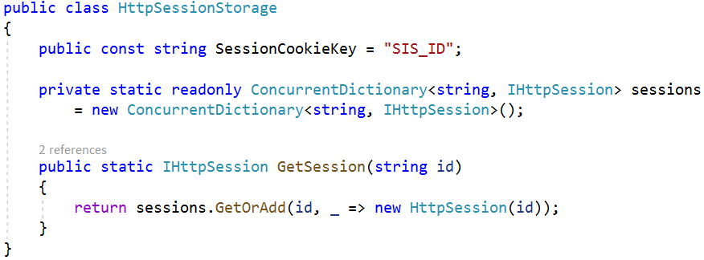

The GetSession() method **retrieves** a Session from the **Session Storage collection** if it **exists**, or **adds** it and **then retrieves** it, if it **does NOT exist**.

And with this we are ready with our HttpSessionStorage. Now it’s time to include all we’ve created so far in the main business logic of our **Server**.

## Server

We have to add the Sessions functionality to our ConnectionHandler, in order for it to be linked with the **Client**.

The following things must be included in our logic:

* **Initialize** the Request Session – **Check** if the Request contains a Cookie with the **SIS Session Key**.
  + If **there is**:
    - **Extract** the **value** of the Cookie (which will be the **id** of the Session).
    - **Use** the **id** to **extract** the Session from the Session storage.
    - **Set** it to the Request’s Session property.
  + If **there isn’t**:
    - **Generate** a **new GuID**, create a **new Session** with it.
    - **Add** the new Session to the Session storage.
    - **Set** it to the Request’s Session property.
  + This should be achieved by **adding** the **following method** to the ConnectionHandler class:

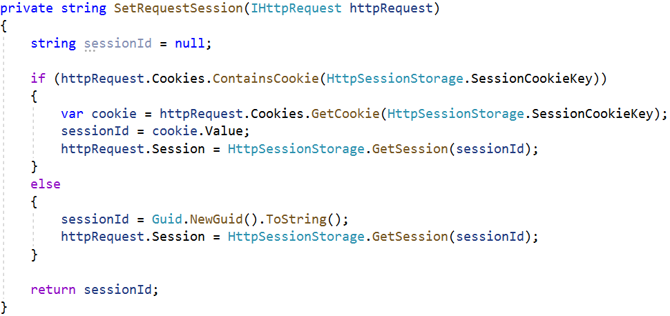

* **Initialize** the Response Session – **Add** a Cookie with the **SIS Session Key** as **Cookie key**, and the Request’s session id, as **Cookie value**
  + This should be achieved by **adding** the **following method** to the ConnectionHandler class:

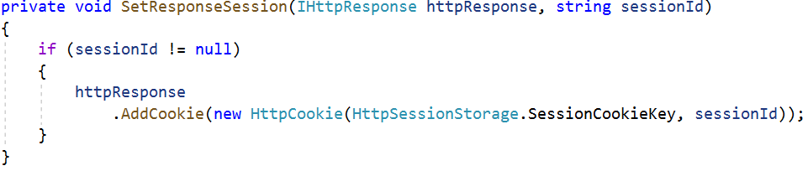

The **invocation** of these methods should be **performed** while **processing** the Request. Modify the ProcessRequest() method like this:

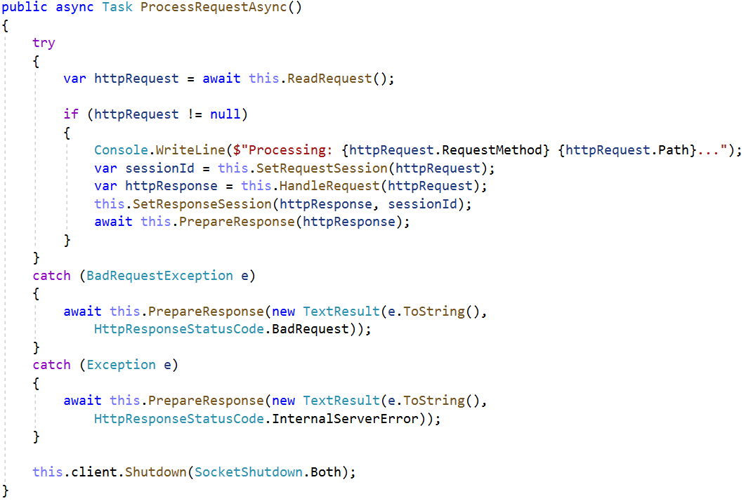

And this should do for now. We have **implemented** a very simple **State Management** mechanism in our **SIS**’s **HTTP Server**.

As the Server is implement, currently, it generates a Session for every connected client. That Session however is **manipulatable**, and we can **add parameters** to it. **Parameters** such as username for example. Such parameters may be used to **indicate** if the **Client** is **logged in**, or what are his **permissions** at our application.

**Test It Out**

